DBMS Technical Task
Dhanalakshmi K
E25AI110
BSc. Computer Science
With
Artificial Intelligence

Week 2: Product and Category Management System

1.Create Product and Category Tables:
Product Table:
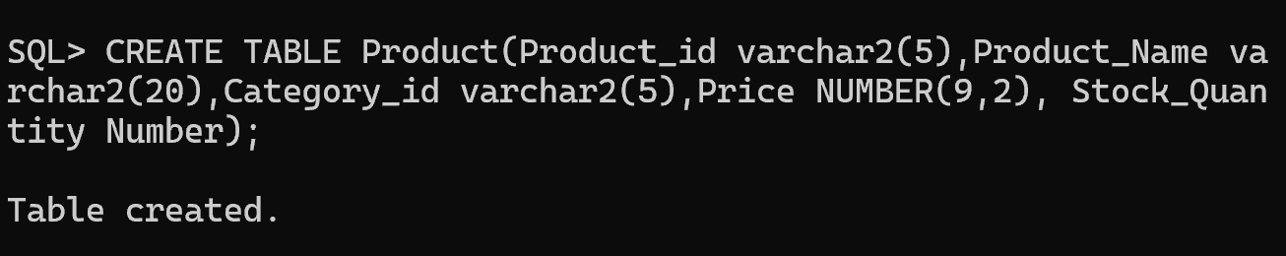
Category Table:
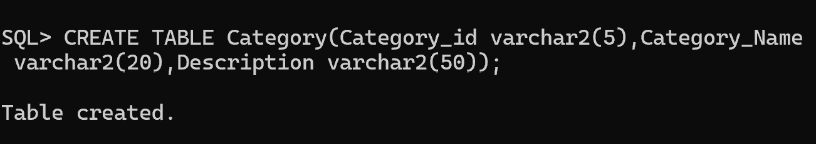
The two tables are created ,now we have to find the relationships between the tables and add constraints for these two tables.

2. Define Relationships and Constraints:

Relationship Between Category and Product
- A single Category can contain multiple Products. Therefore, the relationship between the Category and Product entities is One-to-Many (1 → *).
- After identifying the type of relationship, we need to determine which key is used to establish the connection between these two tables. Before understanding this, it is important to know about Key Constraints.
Primary Key:
A Primary Key is a column or a combination of columns that uniquely identifies each record (row/tuple) in a table.
In the given two tables:
- In the Category table, Category_ID contains a unique value for every category. Therefore, Category_ID can be used as the Primary Key.
- Similarly, in the Product table, Product_ID uniquely identifies each product. Hence, Product_ID is the Primary Key of the Product table.
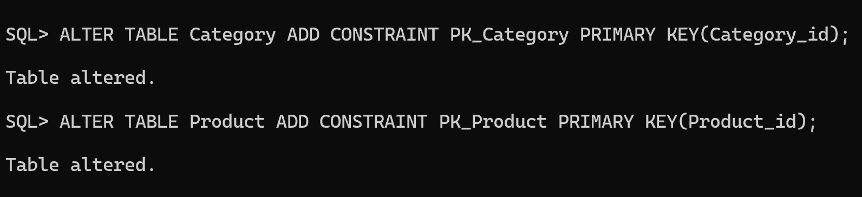
Foreign Key:
- A Foreign Key is a key used to establish a connection between two related tables.
- Therefore, Category_ID in the Product table is used as the Foreign Key because it refers to the Category_ID in the Category table.
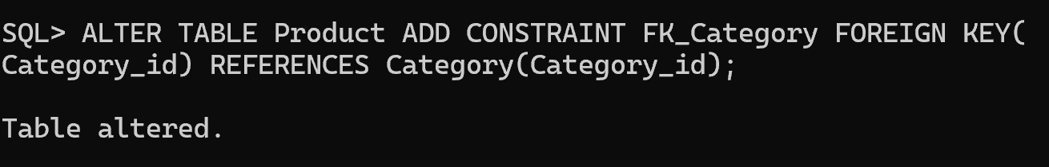

NOT NULL Constraint
- The NOT NULL constraint ensures that a column must always contain a value and cannot be left empty (NULL).
- For example, the Product Name and Category Name should not be empty because every product and category must have a proper name.
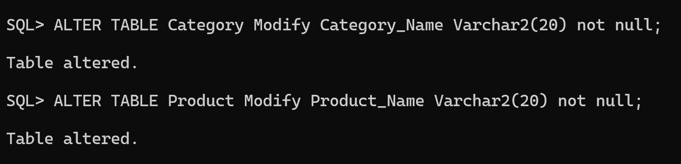

CHECK Constraint:
The CHECK constraint is used to ensure that the values entered in a column follow a specific condition or rule.
For example, the Price of a product should always be a positive value. Therefore, a CHECK constraint can be used to make sure that the price is greater than zero.
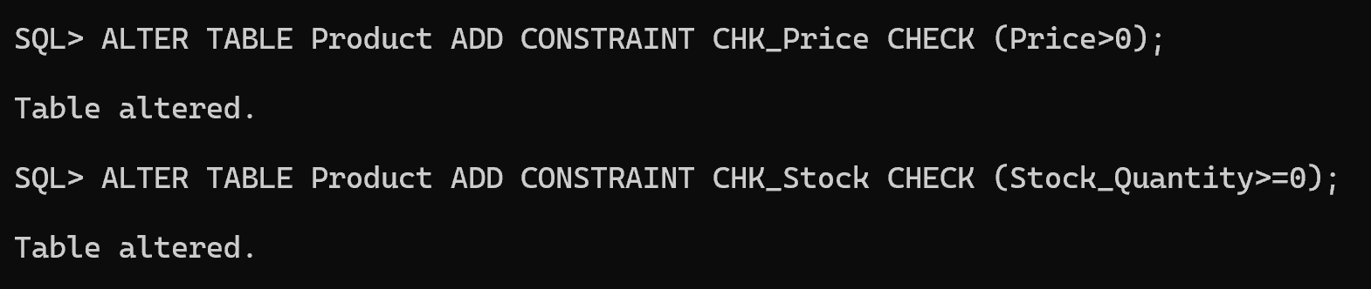

UNIQUE Constraint
The UNIQUE constraint ensures that a column does not contain duplicate values. Each value in that column must be different from the others.
For example, if the Category Name column has a UNIQUE constraint, the same category name cannot be entered more than once.
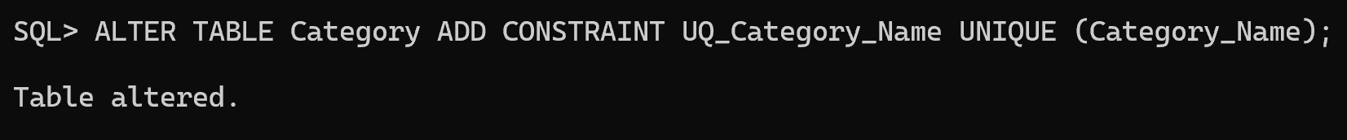

3. Insert Values into Category table:
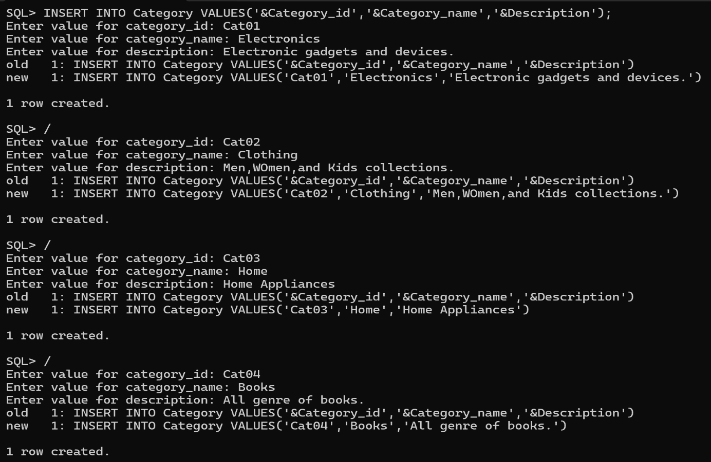

4. Insert Values into Product table :
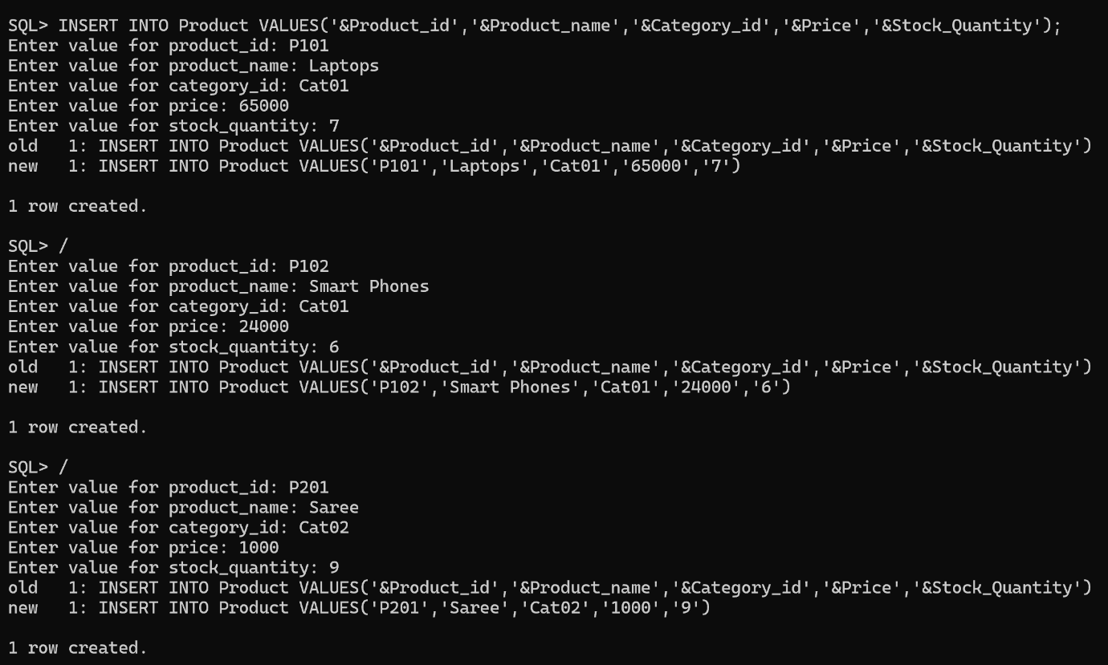
After Insertion of Category Table and Product Table :
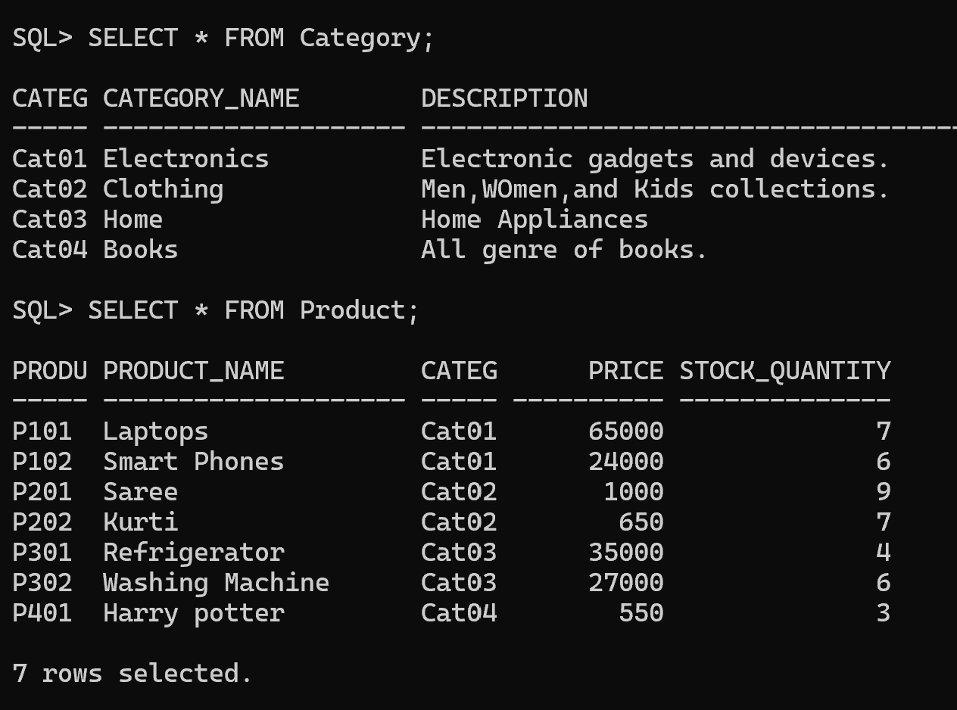
CRUD Operations:
Insert Record:
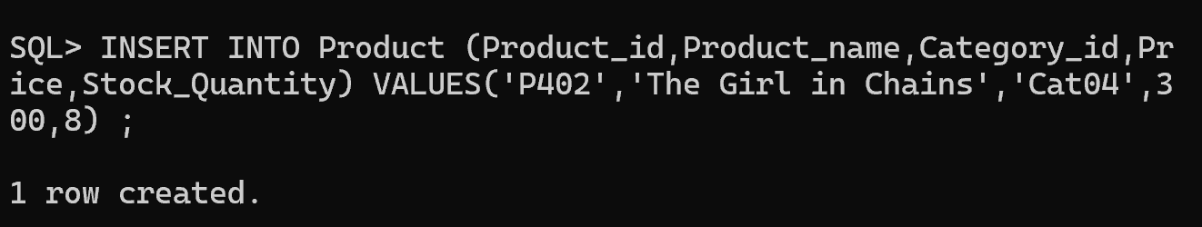
Update Price:
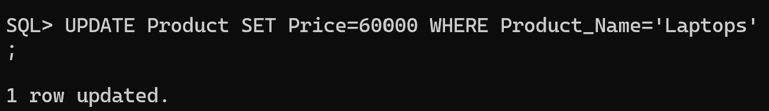

Delete a Product:
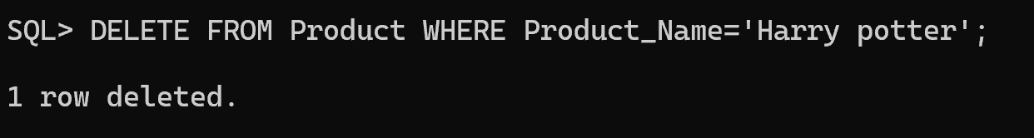

5. Generate Category-wise Product Reports:
Display all products under each category.
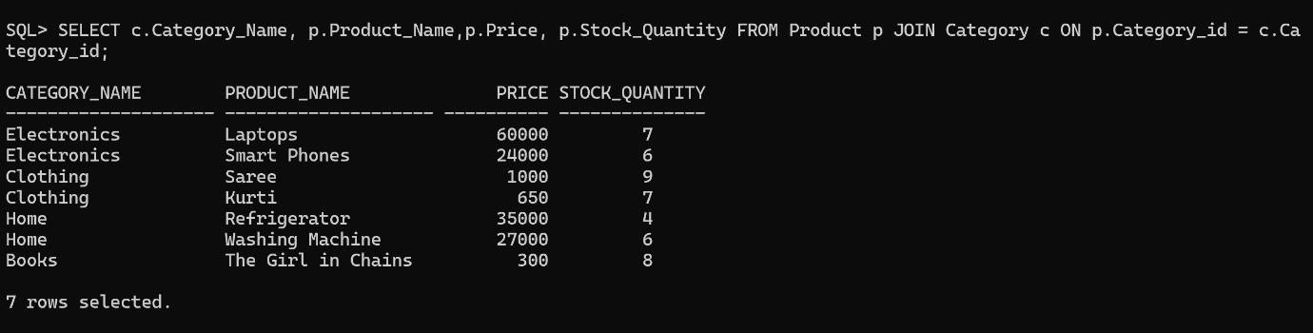

Count number of products in each category.
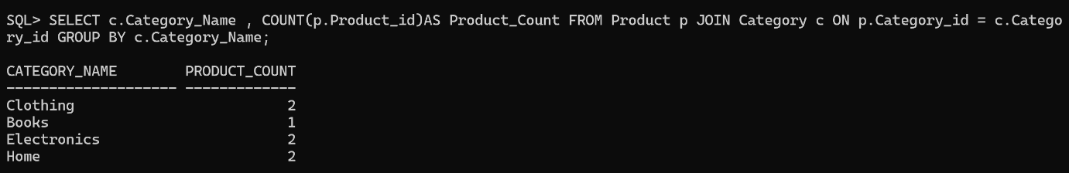

Find highest-priced product in each category.
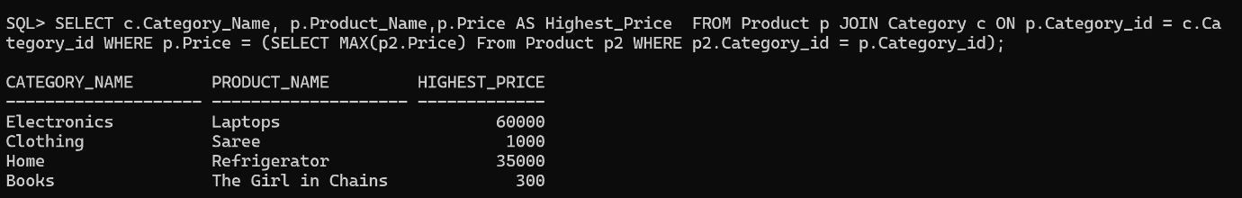

Display categories having more than 5 products.
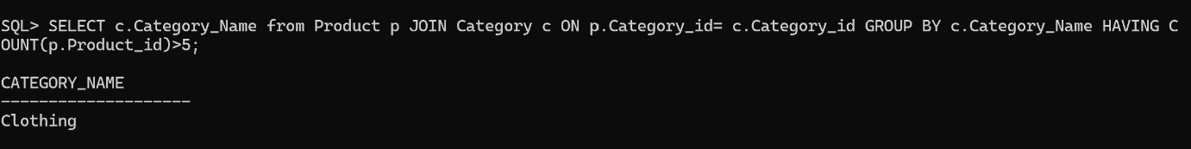

Find average product price category-wise.
